ASSIGNMENT NO-13

Problem Statement:- Create a workmail for your organization. Steps:-

1. **Sign in.** Sign in to your **AWS account**.
2. Search **WorkMail**.

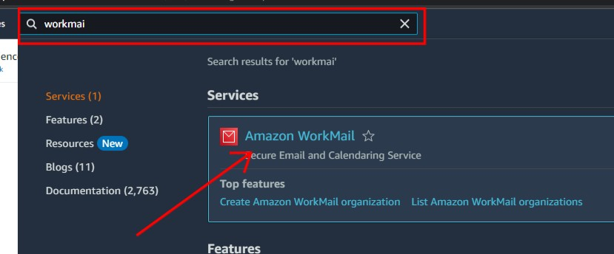

1. Click on **create organization** to create an organization.

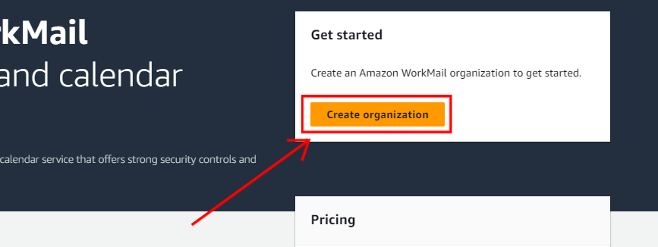

1. Click on **Free test domain**, after that enter your **organization name**.

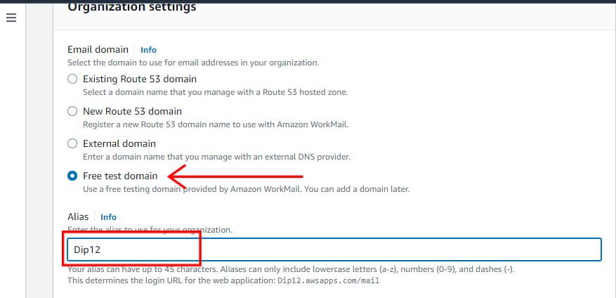

1. In the advance settings, set **user direction** as **Create Amazon WorkMail directory** and set **encryption** as **Use Amazon WorkMail key**. And Click on **create organization**.

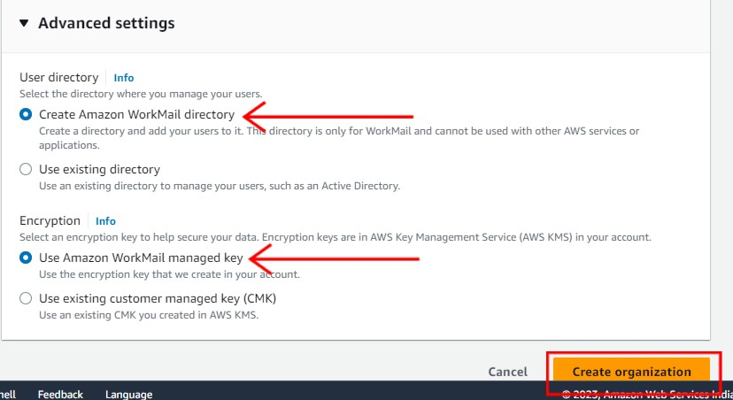

1. Click on the **organization name**.

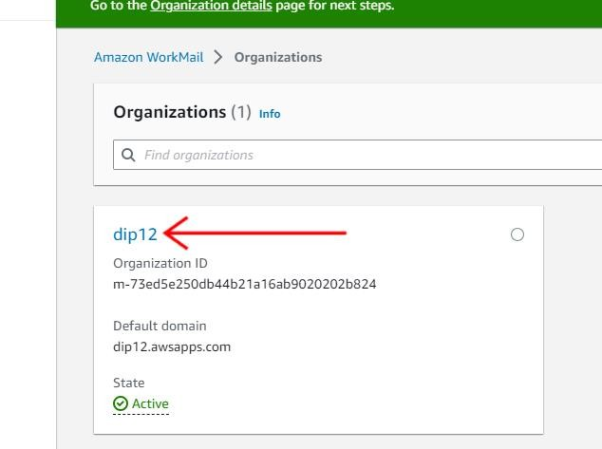

1. After that click on **user**.

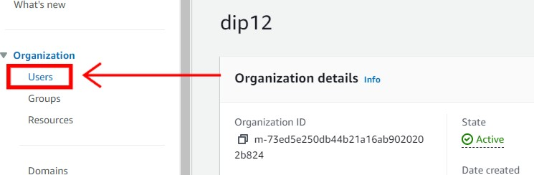

1. Now click on **create user** to add users.

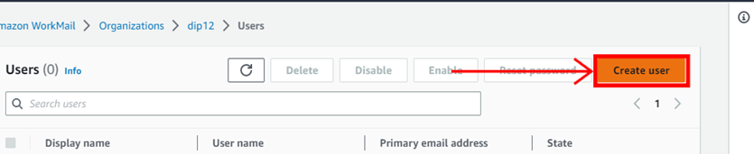

1. Now enter the **user name**, **user’s first name**, **last name** and **display name**.

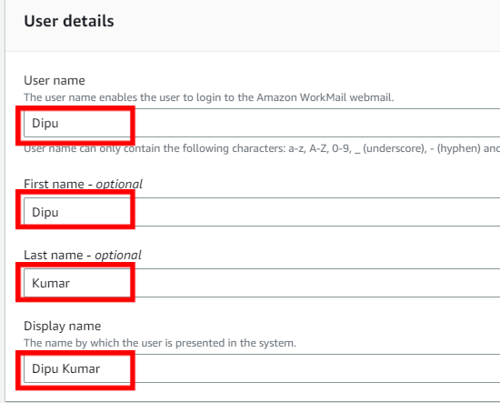

1. Enter the **email address and password** of the user.

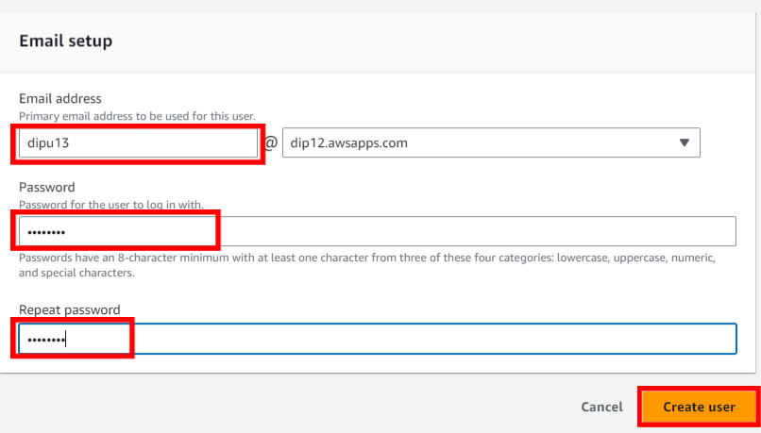

1. Now enter the **user name and password** of the user.

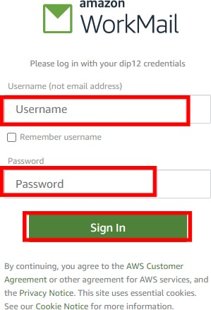

1. This is the interface of amazon workmail.

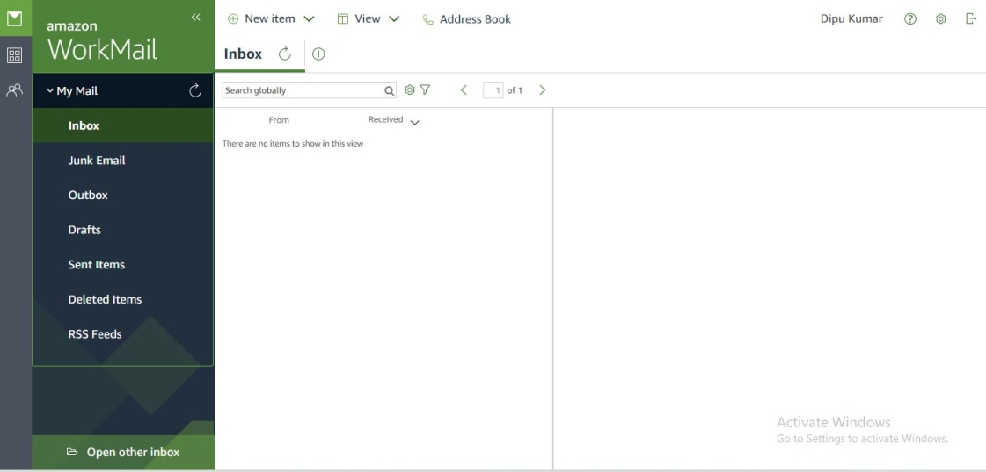

1. Received a mail in indox.

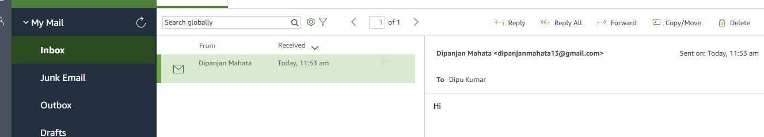

1. Send a mail.

